Brian Kang

HW Set #5

Hw_lect9_1

a. mean = 20*0.25 = 5, var = 20*0.25*0.75 = 3.75, std dev = sqrt(3.75) = 1.936 (about 2)

p(5-2<x<5+2) = 0.7858 – 0.2252 = **0.5606**

b. mean = var = 5, std dev = 2.236 (about 2)

p(5-2<=x<=5+2) = 0.86663 – 0.12465 = **0.74198**

c. mean = 5, var = 1, std = 1

f(5-1<x<5+1) = 0.8413 - 0.1587 = **0.6826**

**# hw_lect9_2**

# a)

x <- runif(1000, -1, 1)

qqnorm(x)

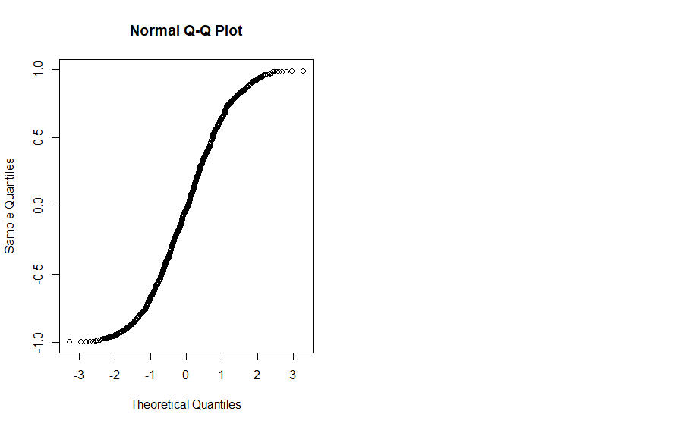

# b)

# -infinity, 0, +infinity respectively

# c)

# -1, 0, 1 respectively

# (CONT. on paper...)

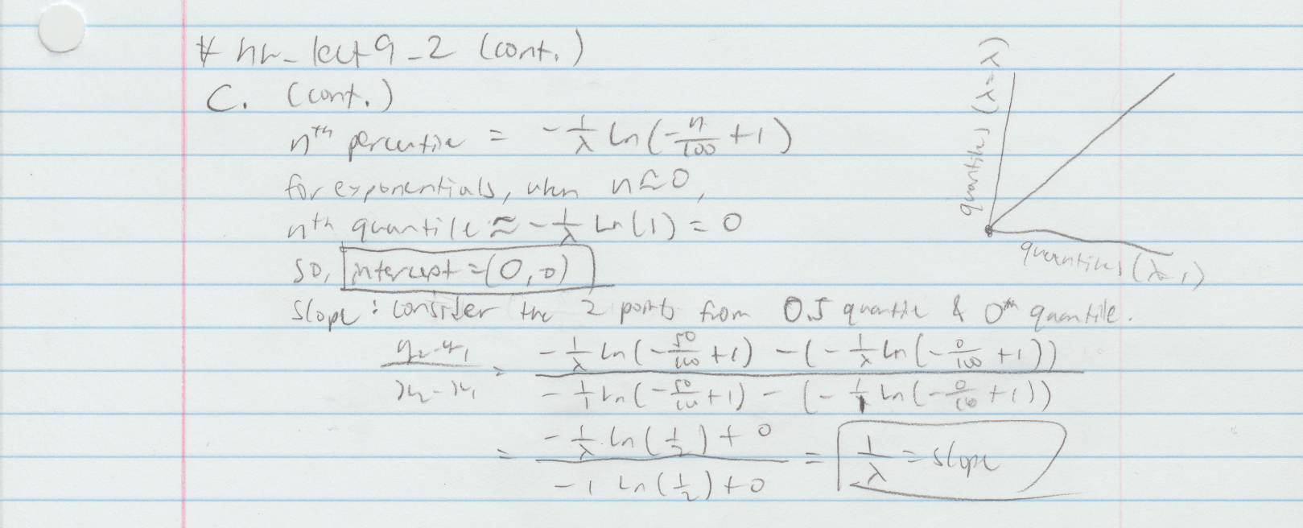

**# hw_lect9_3**

library(Zelig)

data("PErisk")

dat <- PErisk[,c("barb2", "prsexp2", "prscorr2", "gdpw2")]

# display both qqplots

par(mfrow = c(1,2))

qqnorm(dat$barb2)

qqnorm(dat$gdpw2)

# graph below …

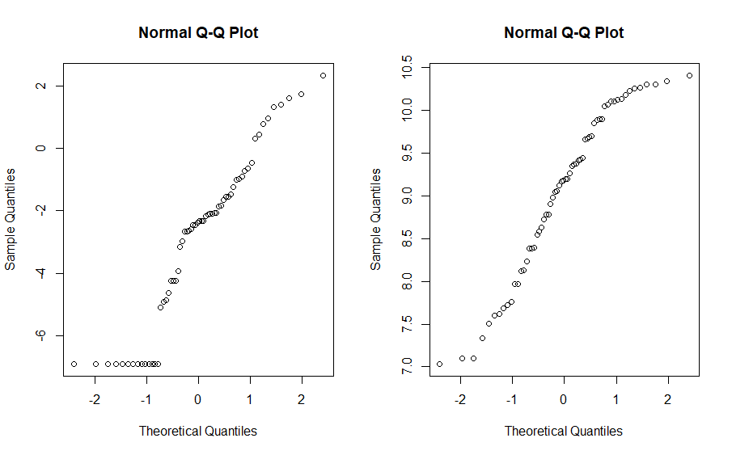

# Starting with the second qqplot, we might be able to say

# that the sample is generally consistent with a standard

# normal because there is a single line that can be drawn

# along the points in the general middle, but if we consider

# the left and right tails, we can possibly see that it can

# follow the shape of the uniform v. normal qqplot from

# hw_lect9_2 A (my sample has that slight S shape generally).

# The intercept at x=0 is around y=9.25 and that seems like

# the general location of the center.

# qqplot(runif(1000,-5,5), dat$gdpw2, main = "Sample2 v. Uniform")

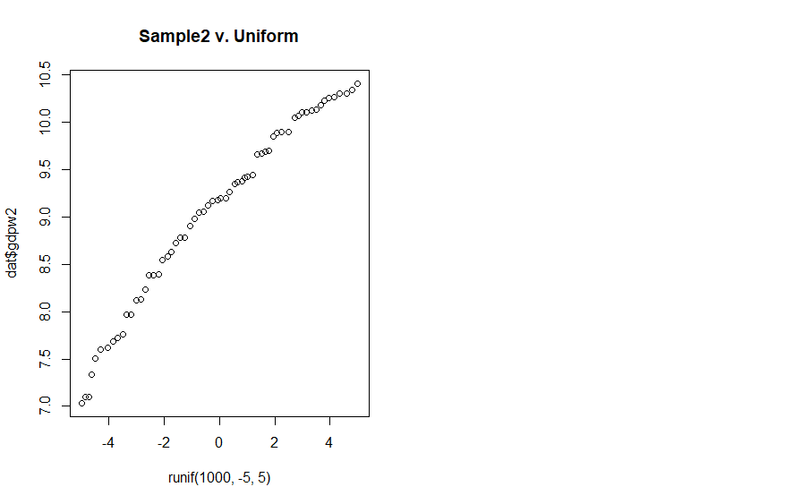

# The qqplot of this sample v. uniform dist. seems promising.

# Now, the first qqplot. It is hard to say that this sample

# is consistent with a standard normal distribution. We can

# see a roughtly straight line from the middle to the top

# right, but the bottom and left is different. We can see

# a horizontal line along the consisten very negative values

# at the very bottom, but the values between these points to

# the middle seem to show a different straight line apart from

# the others. The intercept at x=0 is around y=-1 where a

# cluster of values are located. But I don't think that is

# is very useful for the overall picture.

**# hw_lect9_4**

plot(dat$barb2, dat$gdpw2)

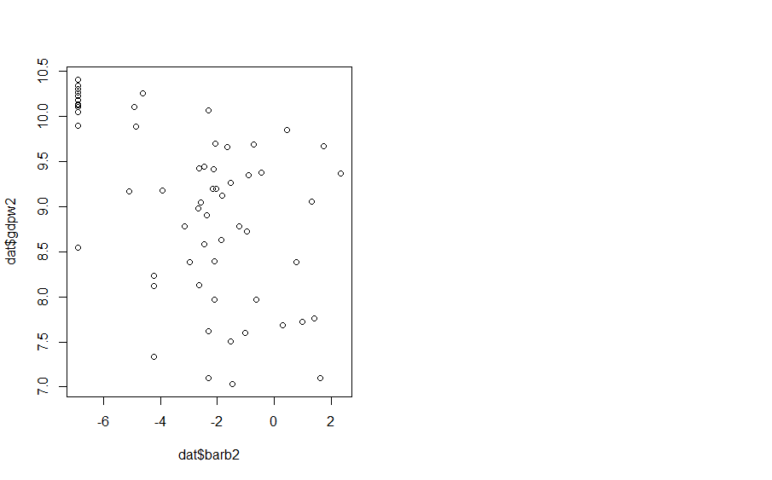

# There seems to be almost no relation between the two data.

# The data seems to be scattered randomly except the top left

# corcer. If we really had to say that there is a certain

# shape, I would say it is one with linear and non-constant-

# -very-wide variance pointing from the top left to opposite.

# But still there seems to be very unlike to be associated.

# remaining problems below…

